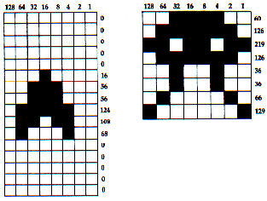

50 FOR ROWS=1 TO SIZE1
60 READ DOTS
70 SHIP$(ROWS,ROWS)=CHR$(DOTS)
80 NEXT ROWS
90 DATA 0,0,0,0,0
100 DATA 16,56,56,124,108,68
110 DATA 0,0,0,0,0
120 FOR ROWS=1 TO SIZE2
130 READ DOTS
140 ALIEN$(ROWS,ROWS)=CHR$(DOTS)
150 NEXT ROWS
160 DATA 60,126,219,126,36,36,66,129

