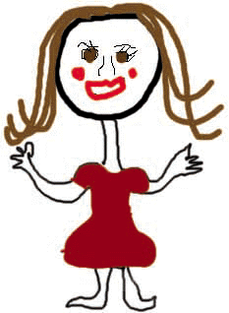
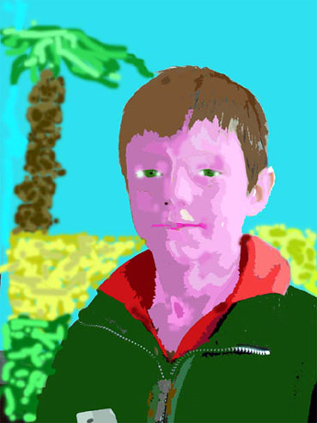

Task 1 - Self-portrait

Create a picture of you in ten years time.

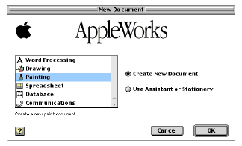
Think about what you will be doing in ten years.
- What job will you do?
- What will you look like?
- Where will you be?

Starting a new painting
- Open Appleworks and create a new painting.
(Click on Painting in Starting Points or go to the File menu, select New then Painting)

Try and use lots of different painting tools.
- What do all the buttons do?
- Use the pencil, paintbrush, paint bucket and the spraycan. How are they different?
- Try changing colours and fill patterns.

Hint - If you’re not sure what a button does, move your mouse over the button and wait. A box will appear telling you what the button does.
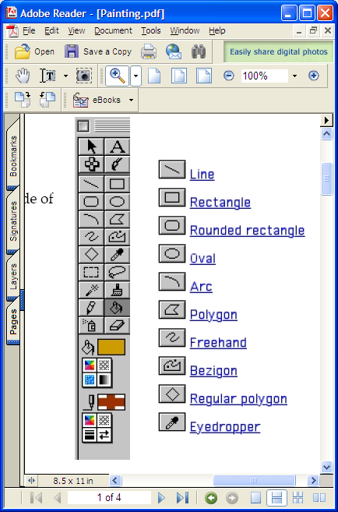
If you do something wrong:
- Click the Edit menu and select Undo
Lasso
Paintbrush
Paint bucket
Eraser
Selection
Mask wand
Pencil
Spray can
- or use the eraser tool.

Remember to save your picture when you finish.
- Go to the File menu and click Save As
- Click Desktop
- Open your class folder, then your folder
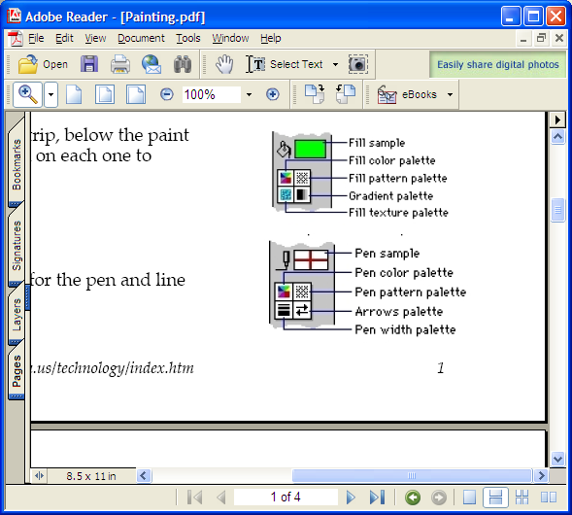
- Name the file (something you’ll remember, like me-in-the-future)
- Click Save.

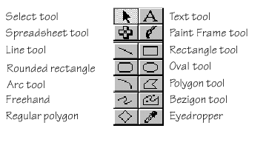




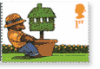
Task 2 - Mini Pictures

Create a mini picture.

Look at the Mini Pictures activity sheet. Choose ONE of the activities below.

If you use a Messenger program at home, like AIM, MSN or Yahoo, then you can design a picture that will be shown to your friends when you are chatting to them online.

If you don’t chat online, then you can design your own stamp. Remember to include the price of the stamp and a head (it doesn’t have to be the Queen’s head).
- You could design an operator logo for a mobile phone.

Tick one of the boxes to show which activity you are doing:

Messenger pic | Stamp | Phone logo

Tick
when
done

Start a mini picture
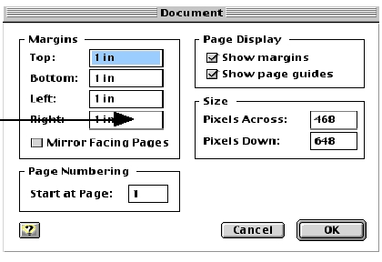
- Open Appleworks and create a new painting. Go to the File menu, select New then Painting.

- Go to the Format menu, and click on Document

- In the box that says Size, you can change the numbers of pixels across and pixels down. Look at the activity sheet and look for the number of pixels across and down for your activity. Enter the numbers.

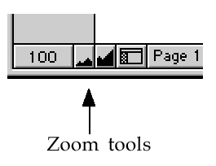
- Your page will have got smaller. You can zoom in using the mountain zoom buttons at the bottom of the window.

- Draw your picture. Try and use the pencil, paintbrush, paint bucket and the spraycan.

Remember to save your picture when you finish

- Go to the File menu and click Save As
- Click Desktop
- Open your class folder, then your folder
- Name the file (something you’ll remember, like minipic)
- Click Save.

Mini Pictures – Activity Sheet

Option 1 - Make your own Buddy Icon



Create a AIM Buddy icon
50 pixels across
50 pixels down






Create a Display Picture for MSN and Yahoo! Messenger

96 pixels across
96 pixels down





- Save the file in your folder as a .bmp .jpg or .gif file.
- Open up Internet Explorer and email your picture to yourself at home.
- At home, save the picture, then add it in MSN, AIM or Yahoo.

Option 2 - Design your own Stamp

Remember to put the price and a head on your stamp
(it doesn’t have to be the Queen’s head.)

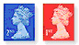
116 pixels across
85 pixels down

57 pixels across
68 pixels down

Option 3 - Design your Nokia operator logo
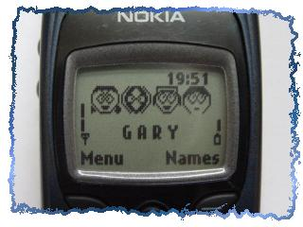

Black and white only – no colours!
72 pixels across, 14 pixels down

Painting Checklist

Name: __________________________

When you can do these things in Appleworks Painting, tick the box:

Use the Pencil

Use the Paintbrush

Change the fill colour

Use the Paintpot

Use the Spraycan
Use the Eraser

Use the Edit / Undo menu option

Make a shape (circle / square / other)

Change the line colour of a shape

Add text to a picture
Change the size of the document

Zoom in and out

Save the picture in your folder

Painting Checklist

Name: __________________________

When you can do these things in Appleworks Painting, tick the box:

Use the Pencil

Use the Paintbrush

Change the fill colour

Use the Paintpot

Use the Spraycan
Use the Eraser

Use the Edit / Undo menu option

Make a shape (circle / square / other)

Change the line colour of a shape

Add text to a picture
Change the size of the document

Zoom in and out

Save the picture in your folder

Appleworks Painting Tools
Lasso
Paintbrush
Paint bucket
Eraser
Selection
Mask wand
Pencil
Spray can

